

**NETWORK ENTERPRISE TECHNOLOGY COMMAND**

General Fund Enterprise Business System (GFEBS)

FY2015 Technical Cost Handbook



Version 1.0

January 2014

**Introduction:**

NETCOM Headquarters has compiled the below information and guidelines to assist NETCOM Fund Holders to correctly identify GFEBS cost collectors (Work Breakdown Structures (WBSs) and Cost Centers) to capture cost. As NETCOM strives to assign, analyze, interpret, and apply costing information against Command, Control, Communications, Computers, and Information Management (C4IM) and other IT Services, it is increasingly important for all Fund Holders to use the requisite cost objects to accurately record costs to ensure validity of financial data reflected on GFEBS reports.

NETCOM guidance is aligned to HQDA Army Budget Office (ABO) and Office of Assistance Chief of Staff for Installation Management (OACSIM) requirements to properly record obligations against correct cost objects in GFEBS. These include, but are not limited to, the assignment of Functional Cost Accounts (FCAs) and WBSs with attributes to identify IT Services. The guidance contained in this document provides a reference tool to establish GFEBS Cost Objects to capture execution costs.

The following information is a detailed compilation of technical guidance and instructions that must be strictly followed and applied by NETCOM Fund Holders. Deviation from the prescribed rules and instructions contained in this document may result in additional work/rework/corrective action to ensure costing information is captured at the mandated level for analysis. As NETCOM works towards the goal of Total Network Enterprise Center (NEC) Cost Visibility it will be critical that Fund Holders work diligently to adjust practices in Fiscal Year 2015 to posture the NETCOM Cost Model to provide accurate tracking of NEC costs.

Questions or concerns regarding the above information can be addressed to the NETCOM Headquarters, G8, Decision Support Team at [usarmy.huachuca.NETCOM.mbx.g8-decision-support-team@mail.mil](mailto:usarmy.huachuca.NETCOM.mbx.g8-decision-support-team@mail.mil).

**Summary Guidelines – NETCOM:**

1) **Overarching Points** - Cost Centers will not be used to track services.

Main Points –

1. Costs will be allocated to secondary Cost Objects - WBS elements by C4IM Service expenditures.
2. Labor (productive time) must be allocated and assigned to the correct Job Order, associated with a WBS, in ATAAPS in order to ensure distribution across the respective IT Services. Cost Centers should not be used as Job Orders in ATAAPS for labor assignment, except for the reporting of leave.
3. Non-productive time will be allocated (by use of ATAAPS) to a specific WBS that has been created to collect these costs at the NEC Director level.
4. Defense Civilian Pay System (DCPS) – Human Resource Module (HR Mini Master) will retain Cost Centers as the default cost object for the payroll default line of accounting by employee (The DCPS Gross Pay File posts payroll against Cost Centers).
5. It is critical that the Faces to Spaces (F2S) file, which contains the Activity Type/Rates for all employees within the organization, be properly maintained. This will be done by the Decision Support Team at HQ NETCOM ACofS, G-8.
   * 1. Updates (Personnel departures, new hires, promotions, details, etc) should be maintained on the F2S file at all times and impacted Activity Rates adjusted in advance of first pay for affected change via transaction code KP26 in GFEBS.
     2. Inaccurate/untimely maintenance of the F2S file and input of KP26 rate adjustments will result in inaccurate allocations from ATAAPS across the 9300 cost elements/commitment items. Distribution is based on input standard rates, not actual.
6. Fully Reimbursable labor (both productive and non-productive) will be allocated to the service level/admin REIM WBSs in ATAAPS.
7. Contracts and other obligating documents must be executed against a WBS identified to the appropriate IT service. Cost Centers must NOT be the primary level of execution/line of accounting, for GFEBS obligating documents/transactions (e.g., FMZ, PO, etc).
   1. Contractor costs for C4IM services will be allocated to service specific WBSs (701.2, 703.4, etc) where possible. If contract costs cannot be broken out by service, the costs will be collected on a summary level WBS (700, 701, 703) and will be further analyzed and allocated to specific services by the HQ NETCOM ACofS G-8, Decision Support Team using statistical key figures (SKFs).
8. Cost Centers will be used in the execution environment only for the purpose of creating an organizational relationship with the WBS. This relationship will be used for the Cost by Cum Partners Report in Business Intelligence (BI).
9. IAW Para C - All interfacing “feeder” systems line of accounting must point to a WBS, where directed (e.g., Defense Travel System (DTS), Access Online (AXOL), Funds Control Module (FCM), PowerTrack (FMZ), etc). For feeder systems that allow a secondary account assignment, one can be identified to the responsible cost center.
   1. For feeder systems using an FMY document (pre-commitment document) to establish the line of accounting, the primary account assignment will be a WBS.
   2. DTS uses its internal line of accounting as opposed to referencing an established feeder document (FMY/FMZ) in GFEBS to create the line of accounting (users input the line of accounting directly into DTS). NETCOM will not be tracking DTS costs using the WBS structure at this time.
   3. PowerTrack references an FMZ document to create the line of accounting.

2) **Projects/WBSs** will be created at the HQ NETCOM G8 level and should be used in all cases, including the following:

A. Reimbursable (Sales Orders) – Public/Federal

B. Direct Charge Reimbursable (GFEBS to GFEBS Activities)

C. Special Funded Programs (e.g., Misc Collections)

D. Other - as approved by NETCOM Headquarters*

General Guidelines

*Effective 1 OCT 2014, IAW GFEBS guidance all NETCOM Fund Holders are required to use new Project Systems (PS) configuration (profiles).*

1. All Non-DPW Projects/WBSs will use the Mission Support SOO (Standard Operating Orders) profile selection designated by an ‘S’ in the numbering sequence (S.XXXXXX).
2. Custom numbering (smart-coding) will be used when the projects are created so the numbers after the first 7 digits match the C4IM Service Catalog designations.

Level 1 (NEC as Project): S.0023032

Level 2 (VTC Service – 701.4): S.0023032.7014

Level 2 (PKI Service – 703.1): S.0023032.7031

1. Key Points -
   1. WBSs have a system defined numbering scheme by level (Level 0 – .XX).
   2. For reimbursable customers, a WBS will be created for each customer as needed at the Service level under the appropriate NEC Project WBS.
   3. Example: Fort Hood NEC provides VTC services to FORSCOM and MEDCOM. The standard Project WBS for Ft. Hood NEC will have been created at HQ NETCOM, as well as the WBS element specifying VTC Service. The budget analyst will create WBS elements under the summary Reimbursable WBS for FORSCOM and MEDCOM:

Level 1 (NEC as Project): S.0023032

Level 2 (VTC Service): S.0023032.7014

Level 3 (Summary Baseline): S.0023032.7014.1

Level 3 (Summary Reim WBS): S.0023032.7014.2

Level 4 (FORSCOM): S.0023032.7014.2.1

Level 4 (MEDCOM): S.0023032.7014.2.2

Refer to the NEC/WBS element crosswalk (PROVIDED AT A LATER DATE) to determine the appropriate WBS element for the service being provided by a specific NEC.

* 1. Fund Holders will need to define the project by the Description Field when creating a customer-level reimbursable WBS as follows:
     1. Include C4IM service number, ‘Reimbursable’ and the customer (i.e. 701.2 – Reimbursable – IMCOM).
  2. Attributes will further define the C4IM service and assignment by ISR.
     1. Each Standard Project Level WBS will be pre-filled with Attributes 1 and 2 (See Annex A). These will allow costs to be collected for a specific service across all NECs.
  3. The Reimbursable Identification Code (RIC) (Annex B) should be populated on all Reimbursable WBS elements as well as Direct Charge WBS elements when NETCOM is the “performing” organization.
  4. FCA must be used in conjunction with Overseas Contingency Operations (OCO) funding requirements as well as expenditures capturing costs for storm damages or natural disasters.
  5. Funded and Released “actions” on any WBS should be performed by two separate users (Basic Data Tab).
     1. Users who perform the FUND/RELEASE actions on a WBS (one of which can be the creator of the Project/WBS) need to validate and verify the project has been established to the correct hierarchy level (Level 4 for all reimbursable customers), confirm all required Funding Data elements (Cust. Enhancement) are populated based on Funded Program Type and Line of Accounting (funding source), ensure Description Field is completed as required (described in next section), as well as verify the Additional Fields tab has been completed in its entirety (based on the Funding Data tab).
  6. Sites can use CN43N to review established Projects (WBS) for their respective Fund Center.

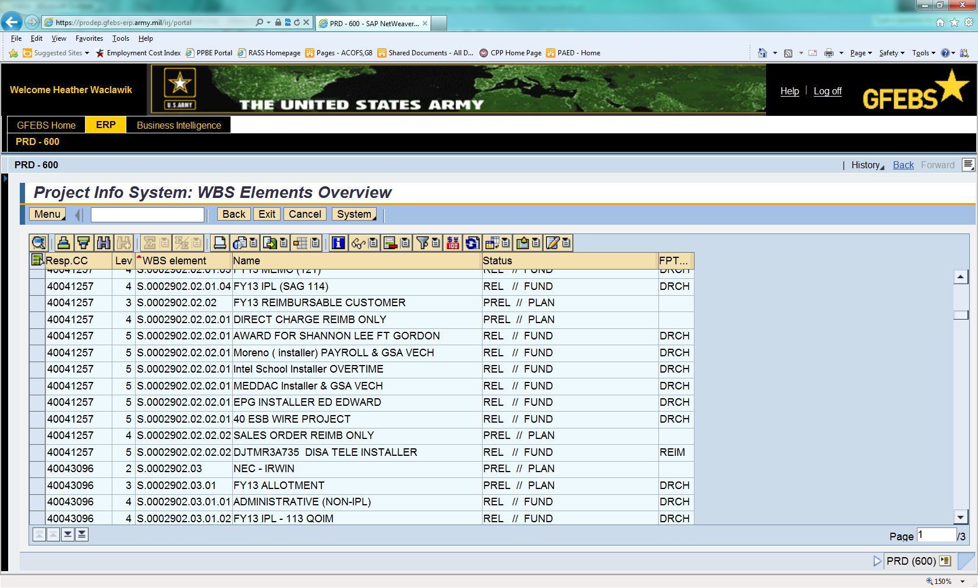

1. Job Aids can be located on the Performance Support Website (<https://prodep.gfebs-erp.army.mil/rwdhelp/nav/index.htm>).
2. Job Aids can be located on the MilWiki Suite for GFEBS (<https://www.milsuite.mil/wiki/Portal:GFEBS>) .

Reimbursable/Direct Charge Projects/WBSs:

Specific Guidelines

1. Automatic Fund (Reimbursable Sales Order) WBSs should always have funded program type: REIM selected and use the A - “Automatic” - fund assignment on CJ20N screen tab Cust. Enhancement > Funding Data tab.
   1. Enter the RIC on the Cust. Enhancement > Funding Data tab according to the service being provided (See Annex B).

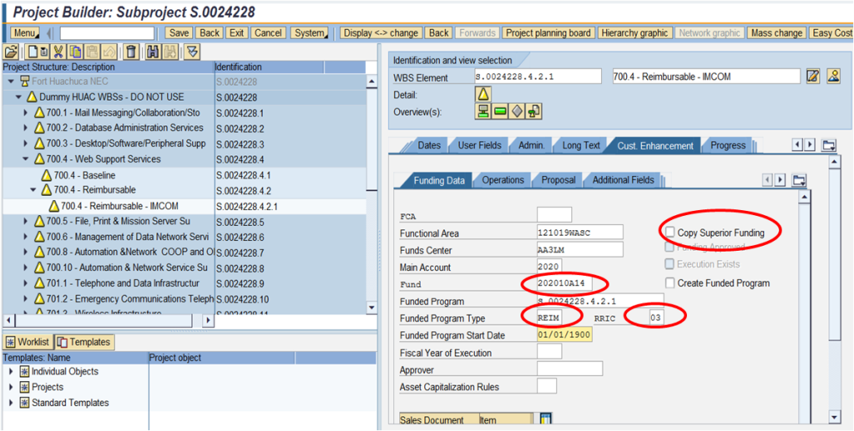

* 1. NETCOM attributes cannot be pre-filled for customer-level WBSs at the HQ NETCOM level and must be completed by the Budget Analyst.
  2. Enter Attributes 1 and 2 into the Cust. Enhancement > Additional Fields tab according to the service being provided (See Annex A).

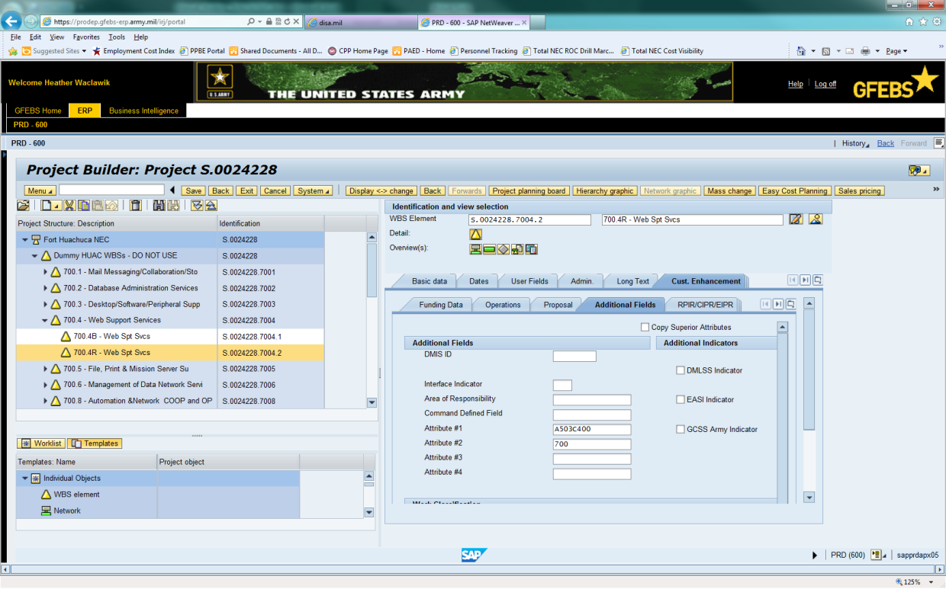

1. Direct Charge WBSs should always have funded program type: DRCH.
   1. NETCOM pre-filled attributes at the Project level will not be used since the customer must put their information in the fields. Therefore, the budget analyst will include the following when creating Direct Charge customer-level WBSs:
      1. Begin the “Description Field” of the WBS element with the numerical code specifying the C4IM service being provided. Then write ‘Reimbursable’, followed by the customer name.

i.e. 701.3 – Reimbursable – IMCOM

* + 1. Under the description in the Long Text tab, write attribute 1 and 2 codes and RIC.

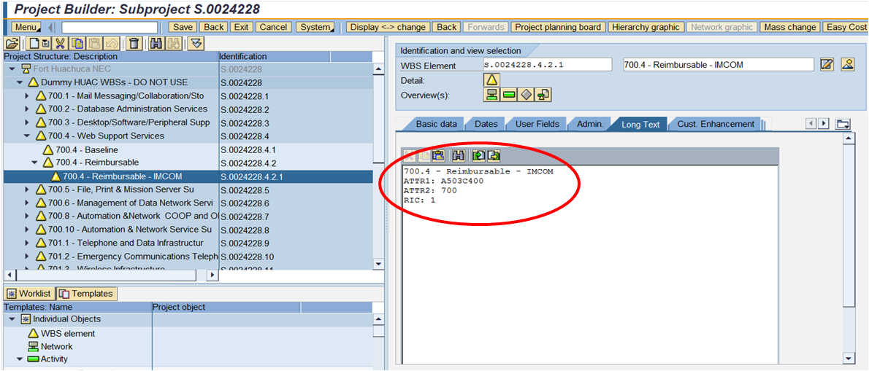

1. All view fields – FCA (as applicable), Attributes 1 and 2, Interface Indicator if required (ATAAPS Labor only) and RIC should be completed on WBS before it is Funded and Released.
   1. Brigade/Battalion-level Budget Analysts will NOT use the Interface Indicator field when completing customer-level (Level 4) reimbursable WBSs.
2. IAW existing GFEBS instructions, a summary Reimbursable Project hierarchy for the fiscal year will be established (part of WBS batch upload performed at HQ NETCOM) and Fund Holders will build appropriate child WBS elements to capture reimbursable tenants/customers instead of having numerous project profiles to manage.
3. Multi-Service Reimbursable requirements will be created under the Summary Level WBS for the 700, 701, or 703 series (always at the bottom of the WBS list).
   1. E.g. A requirement for Telephone, Wireless, and VTC services will go into the “701 Series Summary – Communication Svcs” WBS.
   2. In the Long Text tab, list the services included and, if possible, associated $ amounts.

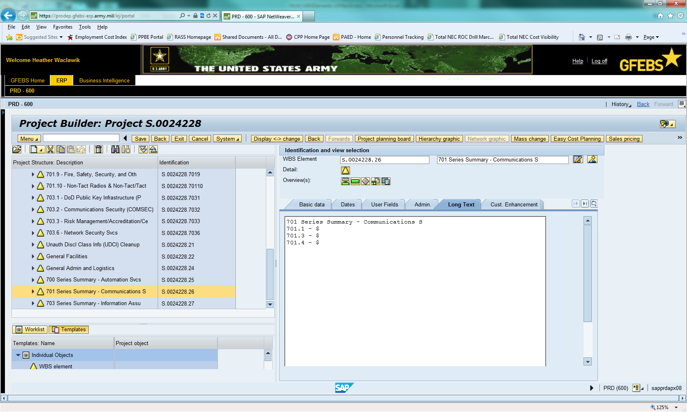

1. Multi-Series Reimbursable requirements should go under the Summary WBS that the majority of the requirement falls under.
   1. E.g. A requirement for IA, Wireless, and Web Support Services will go into the 700, 701, or 703 Series Summary, according to where the greatest $ amount of work falls.
   2. 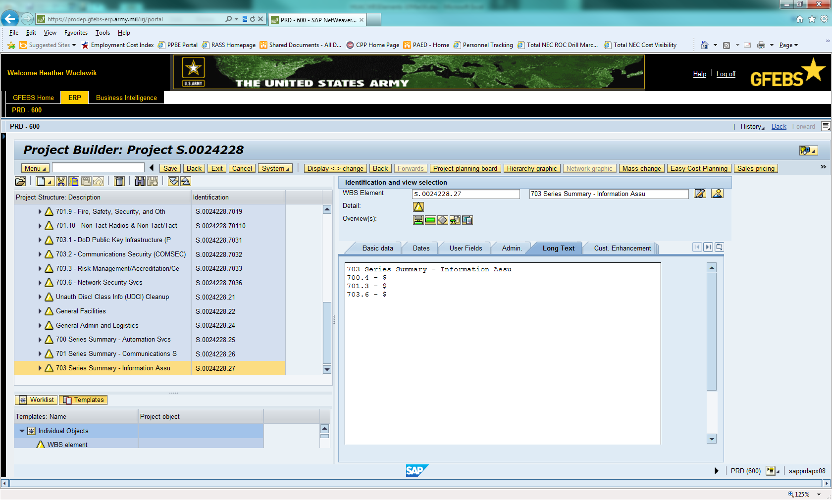In the Long Text tab, list the services included and, if possible, associated $ amounts.

Generic Funded Program Type/WBS:

Specific Guidelines

1. GENR type WBSs should only be used for internal WBS execution when not executing a reimbursable or direct charge requirement.
2. Funded Program will be set at ARMY, so funding availability control and validation rolls to the SAG. HQ NETCOM will set Funded Program to ARMY for all Direct Funded WBSs.
3. HQ NETCOM will routinely scrub established funded programs across Command to ensure compliance.

Differing Functional Areas:

Guidelines

1. CONUS
   1. Since the majority of CONUS IT Services are paid for through 131050QOIM or 131R50QOIM, all Level 1 – 3 WBSs for CONUS NECs will be created using one of these Functional Areas (depending on whether the NEC receives OMAR funding). If a requirement uses 131050QOIM or 131R50QOIM, copy the superior funding for creating a new WBS.
   2. When a requirement within a Functional Area other than 131050QOIM or 131R50QOIM arises, contact the HQ NETCOM G8 Decision Support Team at [usarmy.huachuca.NETCOM.mbx.g8-decision-support-team@mail.mil](mailto:usarmy.huachuca.NETCOM.mbx.g8-decision-support-team@mail.mil) and provide the following information:
      1. NEC providing the service
      2. C4IM Service being provided
      3. Functional Area
      4. Funds Center
      5. Cost Center
      6. Plant
      7. Fund
      8. Whether the requirement is GENR (NETCOM Funded), DRCH, or REIM
      9. Whether the WBS needs to be available in ATAAPS for labor tracking

A member of the Decision Support Team will set up the WBS for you in the appropriate area of the WBS project for that NEC.

1. OCONUS
   1. Same guidelines as above except that WBSs will be created using WASC and/or QOIM Functional Area and requirements outside of those will require a separate WBS to be created.

Contract Costs:

Guidelines

1. Contract costs that can be attributed to specific services should post to service-specific, Level 3 – Baseline WBSs (e.g. 700.3 – Baseline, 703.2 – Baseline, etc).
2. Contract costs that cannot be broken out by specific services should post to one of three summary-level WBSs which will exist within each specific NEC hierarchy.



* 1. 700 Series Summary – Automation Services
  2. 701 Series Summary – Communications Services
  3. 703 Series Summary – Information Assurance Services
  4. If possible, denote how much of the contract is attributed to each C4IM Service

1. Persons inputting the Purchase Requisition (PR) in GFEBS will ensure the proper service-specific or summary level WBS is chosen for each line of contract costs instead of using a cost center.
2. Budget Analysts performing the L4 function, will ensure that contract costs are being posted to WBS elements instead of cost centers before certifying.

Defense Travel System (DTS):

Guidelines

1. In order to assign DTS costs to service-specific WBSs, a Line of Accounting must be created in each instance.
2. To minimize the increase in workload, DTS costs will continue to be tracked only by Element of Resource (EOR). DTS will NOT reference the WBSs created for IT services.
3. Instead, DTS costs will be analyzed and distributed among the service-level WBSs by the HQ NETCOM G-8 Decision Support Team.

AXOL (Government Purchase Card):

Guidelines

1. GPC charges must be assigned to service-specific WBS elements through Cost Transfers.
2. Cardholder will keep track of which WBS each transaction relates to and, at the end of each billing cycle, will send a list to Budget Analyst for completion of Cost Transfers to the appropriate WBS elements.
3. HQ NETCOM G8 Budget Analysts provide two suggestions for organizing this process.
   1. At the end of each posting period, cardholder writes the WBS element for each transaction onto the card statement and gives it to the Budget Analyst.

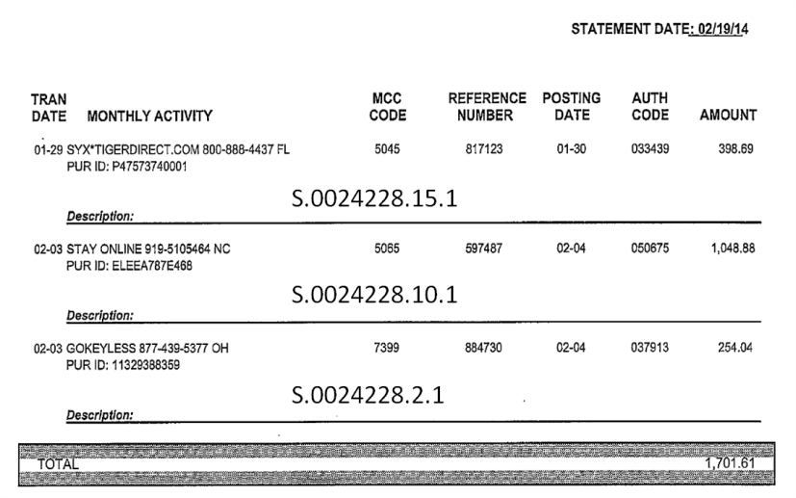

* 1. Cardholder keeps track of transactions throughout the posting period in a spreadsheet and sends to Budget Analyst after comparing with card statement.

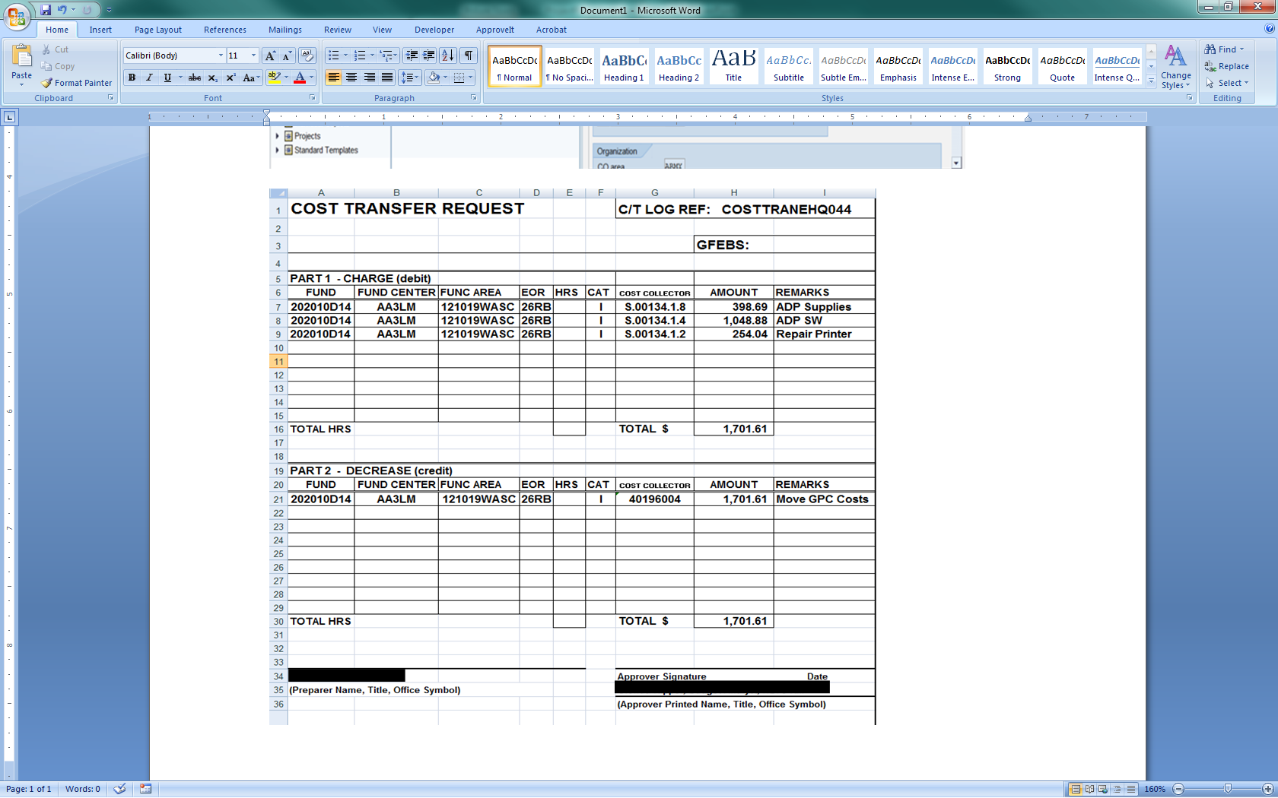

Budget Analyst then completes the cost transfers to the appropriate WBS elements.

* If problems are detected, HQ NETCOM will direct corrective action.

*Fund Holders are not permitted to create Projects/WBSs outside of the scope of requirements listed above without prior approval from NETCOM Headquarters, G8 Financial Operations ICW HQ Budget and Decision Support Teams.*

3) **Cost Centers** represent organizational entities such as a Division, Section, Unit, etc., within the Army structure.

NETCOM Cost Centers have a default ISR assigned for the purpose of capturing residual cost remaining from allocations (e.g., ATAAPS labor).

1. Cost Centers are built as pre-deployment master data and are tied to the approved/latest TDA in the Army's Force Management System (FMSWEB).
2. Cost Centers are static and will not change except for rare circumstances such as reorganizations, transformation, or other personnel impacted actions.
3. Cost Centers are not created to capture IT service costs/expenditures.
4. Executing at Cost Center level will negatively impact your site’s IT service cost tracking and reports.

Example of a Cost Center Master Record –

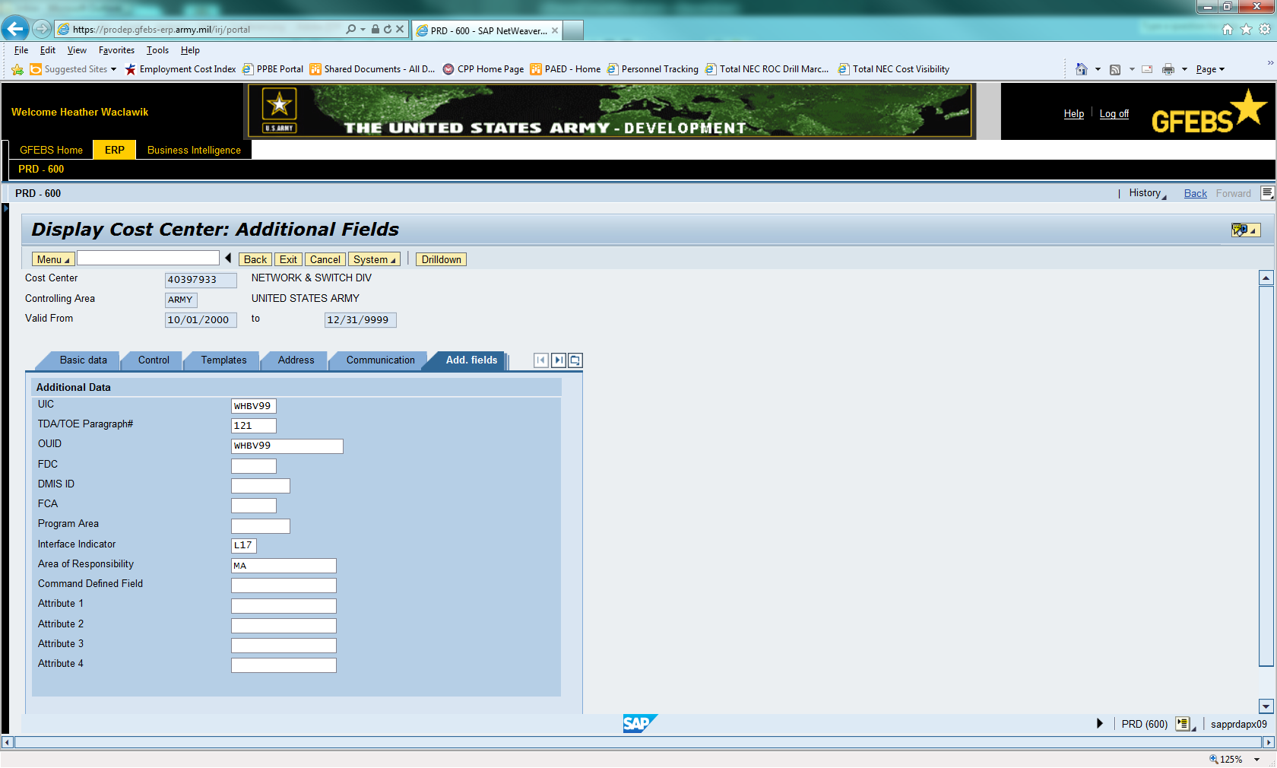

NETCOM does not assign FCA codes or Point Accounts to Cost Centers.

**Basic Rules & Information for Cost Objects**:

1. Attributes are "view" fields that further define/describe the cost object’s purpose and are aligned and consistent with the AMSCO/MDEP/IT service and, if required, FCA. Clarified as follows:
   1. IT service should further define the nature of expense within AMSCO/MDEP
   2. Attribute fields are not permanent on transactional records and will change for the entire history of the individual obligation record if modified (change file)
   3. Once a Cost Object is attached to an obligation record, funding data is permanent on the record (Fund and Functional Area)
   4. All cost objects required for use in ATAAPS labor should have the NETCOM interface indicator code recorded – L17. This is especially important for Reimbursable labor (Level 3 only) as the WBS must have the L17 populated under the Cust. Enhancement > Additional Fields tab
      1. Customer-level (Level 4) reimbursable WBSs should **NOT** include the interface indicator
2. All WBS elements should have appropriate data elements populated including where applicable, FCA code, the Interface Indicator field (ATAAPS Labor), and the C4IM service attribute codes.
   1. WBS Elements cannot be changed via a GFEBS mass change and must be maintained and corrected by the fund center. Please note, once a WBS is Funded and Released, you should not attempt to make changes (specifically on the Funding Data – LOA information)
      1. You can update the FCA field on the Cust. Enhancement > Funding Data tab as well as the Additional Fields tab but the transactional records may not reflect changes made on WBS master data from inception
      2. Never make changes on a Reimbursable WBS after it has been Funded and Released as this may create errors in the system against the assigned Sales Order
   2. WBS changes must only be made by the creator (CJ20N) under the Cust. Enhancement > Additional Fields tab, for the following fields: C4IM service Attribute Codes, Interface Indicator; and in the Cust. Enhancement > Funding Data tab, FCA (note there is not an audit trail of changes on the WBS record)
   3. Verify all data elements for attribute fields are populated correctly before funding and releasing a WBS. Attributes 1 and 2 will be automatically filled when the Level 1 - 3 WBSs are created by HQ NETCOM ACofS G-8, Decision Support Team. However, remember that for reimbursable customer-level (Level 4) WBSs, the Budget Analyst must complete these fields to insure proper cost-tracking
   4. All WBS elements being pre-positioned for use in FY15 must utilize the new Project Systems structure and profiles appropriate for requirement being captured
   5. WBS/Projects may or may not roll from fiscal year to year depending upon GFEBS O&S and ARMY Fiscal Year End guidance. NETCOM recommends rolling over WBS elements to the next fiscal year to reduce workload associated with having to re-create WBSs every year

All changes/updates/create new requests must be sent to GFEBS Helpdesk via Army.GFEBS.Helpdesk@mail.mil or by using Remedy self service. All tickets should include the requisite change or create template (WBS/Cost Center) found on GFEBS MilWiki smart book, cost management. Subject of ticket should read ATTN: NETCOM HQ, your Fund Center and nature of request. No longer will requests be sent to HQ NETCOM POC directly.

Helpful Links:

Smart Book/Cost Management:

<https://www.milsuite.mil/wiki/Portal:GFEBS/Digital_Smart_Book>

**DATA FIELDS TO CONSIDER:**

DESCRIPTION: Describe the purpose/requirement for this C4IM service (detailed: service number, reimbursable, customer name)

NON STATISTICAL - X

STATUS – REL/TECO

FUNDED PROGRAM -

FUND -

FA –

FCA -

Attribute 1 =

Attribute 2 =

Attribute 3 = Blank

Attribute 4 = Blank

Area of Responsibility =

Interface Indicator =

**NETCOM RELEVANT DATA FIELDS**:

ATTR 1 – Pre-filled in WBS levels 1 – 3 to identify C4IM service; use Annex A to determine the code to include in level 4 (customer-level) WBSs

ATTR 2 - ISR – Pre-filled in WBS levels 1 – 3 to identify C4IM service summary level; use Annex A to determine the code to include in level 4 (customer-level) WBSs

ATTR 3 - Not required - temporarily holding CLS SSP

ATTR 4 - Not assigned

FCA - Required if OCO/Storm Damage or other DA identified FCA

RIC – Must be filled in by Budget Analyst for level 4 (customer-level) reimbursable requirements; use Annex B to determine the code to include (NETCOM will always use either 01 or 02).

INTERFACE INDICATOR FIELD - L17 - required for all orders used in ATAAPS for labor allocations (**Do NOT include on Level 4 Reim Customer WBSs**)

**Creating Organization Relationships:** (Dual postings)

WBSs are already assigned to a responsible Cost Center, and this can be viewed in BI reports by bringing in the WBS element and adding the Responsible and Requesting Cost Center from the Attributes tab within Properties/Characteristics menu path.

**ATAAPS Labor** - Cost Objects File

The Interface Indicator field was established for the DISA Cost Objects file for ATAAPS processing. WBS elements will close out in ATAAPS if this field is not inputted.

ATAAPS interfaced records into GFEBS moves cost from the Cost Center (if setup correctly in accordance with NETCOM Guidance) via the 9300 Commitment Item/Cost Element/General Ledger (GL) Account. It is distributed based on the KP26 Activity Rates maintained from the Faces to Spaces file (external document).

1. Distribution is made on a standard rate basis/calculation and will leave a residual balance of actual cost (+/-) at the Cost Center designated.
2. Users must check their ZSCM_TT_ERRORS report routinely after each pay period to ensure all ATAAPS Time Tracking Errors are cleared before the following Pay Period.
3. Even though the function will be available, Fund Holders must not setup the dual posting capability in ATAAPS. There should be one cost object per Job Order.

**WBSs – Defaults/Favorites Setup Example**

Sample Defaults/Favorites for an employee when assigning them a WBS Element.

1. RG hours (Productive Hours) charge to the WBS Element.
2. L-Type hours (Leave) are charged to the Job Order associated with the Team Cost Center particular employee.
3. The following tables depict the old method of tracking time versus the new method.
   1. In the old process, all hours were reported under one Cost Center and Job Order
      1. Only civilian time was tracked with ATAAPS
   2. The new process will require the civilian and military (eventually LN and contractor labor will be tracked in ATAAPS as well) NEC employees to record their time by C4IM service and distinguish between Baseline and Mission Funded services
      1. The Job Order numbers correspond to the WBS elements that are created by HQ NETCOM ACofS G8 and batch-loaded into GFEBS
      2. It is crucial that employees know which services they are performing, whether they are Baseline or Mission Funded, and accurately record that information in ATAAPS each day in order to correctly associate costs with services (See Annex D)
      3. Military time tracked in ATAAPS will be for statistical purposes only
      4. Job Orders will be assigned to each employee by the supervisor

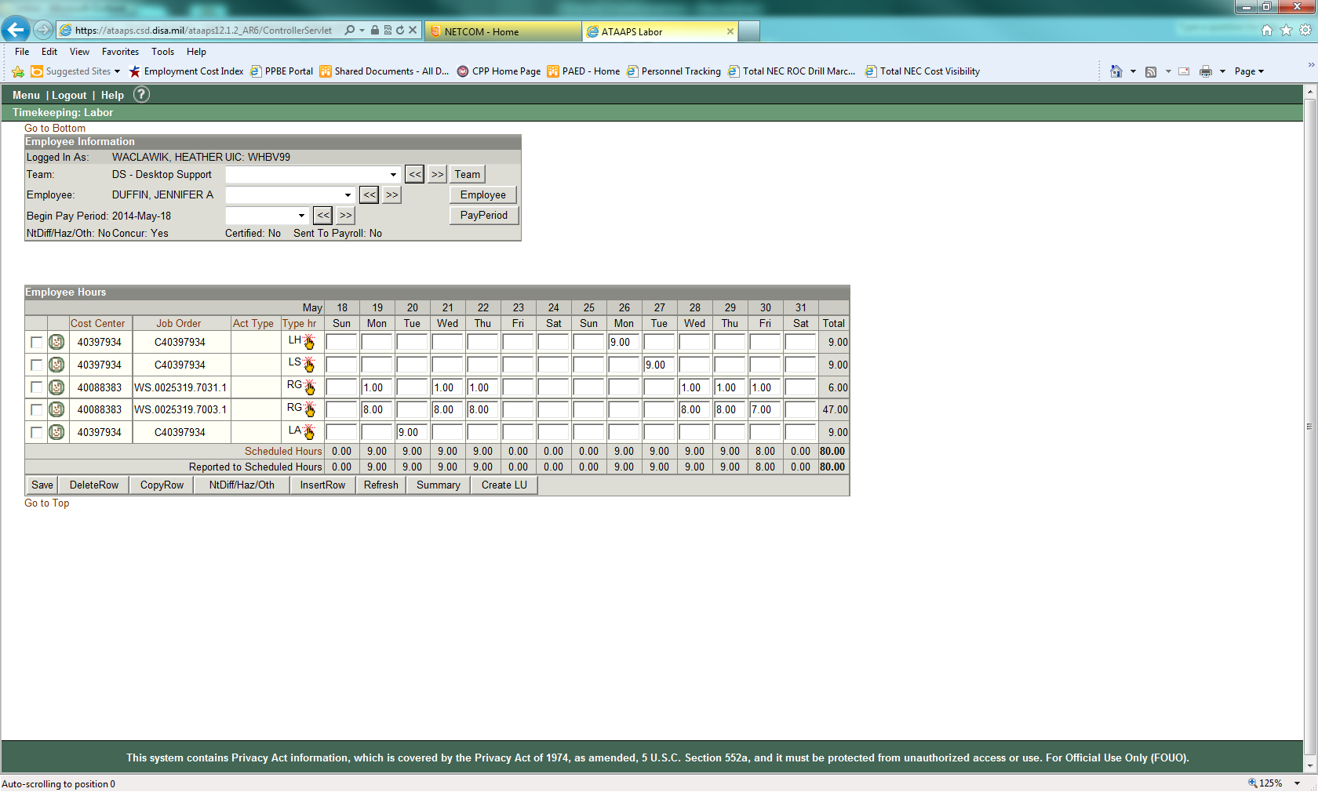

**Refer to Annex D for detailed guidance on relating task to C4IM service for accurate time-tracking.**

**Cost Transfers – Tips & Guidelines:**

When a cost transfer is required, consideration should be made for what type of cost transfer or allocation is appropriate based on the commitment item/cost element as well as nature of transaction. There are specific requirements for the two main types of cost transfers/manual allocations – FV50 Journal Voucher or KB15N Secondary Cost Correction Allocation (manual cost movement that does not touch GL).

1. All Cost Transfers must have documentation on file to support reasoning and justification for performing the FV50 JV (audit requirements).
   1. Take screen shots of the before and after process and have Senior Analyst, Accountant, or Budget Officer/Resource Management Officer validate both before and after, as well as sign off on hard copy document with justification
   2. When moving cost for payroll – you can use the FV50 transaction, document type XZ as long as it is the primary commitment item/cost element (e.g., 11B1 or 6100.11B1)
   3. Never perform the FV50 transaction type on 9300, 9300L, 9300F, 9300C, or 9300N as this will create improper postings within the FM module, FI module, and BI reports (system should now prevent this from posting)
      1. 9300 ATAAPS or other movements are reallocated using KB15N-Secondary Cost Corrections (reference job aid)
      2. When moving 9300L or 9300.0100/9300.010T – cite 9300.01VR in the KB15N document (manual cost allocation)
      3. Also reference the Cost Transfer Decision Matrix materials and job aids before completing a cost transfer. Job Aids can be found at the PSW or MilWiki sites
   4. Standard (non-labor) FV50 Journal Voucher document type is SB (GL Account Posting). If document type is not visible on main screen of FV50 click EDITING OPTIONS at top of screen, look for drop down selection box at lower right corner, and select “Ready for Input” option – Click BACK
2. Please follow GFEBS job aid and reference material instructions regarding cost transfers and manual allocations.

**Summary**

1. Primary costs are posted in the 6000 series accounts and are moved via FV50 using G/L account documents. There are specific document types when using FV50 based on type of cost being moved (e.g., labor XZ or non-labor, SB).
2. Secondary costs are posted in 9000 series accounts (e.g., 9100, 9300) and are allocated between Army organizations within GFEBS for labor, overhead, or other cost allocations. These are moved only by using KB15N – Manual Cost Allocation. See Annex C for 9300 Accounts.

**Major Steps** (reference Cost Transfer Decision Matrix Job Aid – copied here for quick reference)**:** Link to GFEBS job aid <https://www.milsuite.mil/wiki/Cost_Transfer_Decision_Matrix>.

1. Determine if your cost transfer falls under one of the 3 categories:
   1. Primary Cost Correction
      1. Primary Cost Corrections are done when a primary cost element (6000 series) has posted incorrectly

Example: Your DCPS Payroll posted to an incorrect fund and needs to be corrected

* 1. Cost Allocation

1. Cost Allocations are periodic settlements of costs based on drivers such as activity rates and hours worked. Cost allocations are always posted using a secondary cost element (9000 series) which are accounts established by DASA-CE
2. A cost allocation is not used if a posting was made to an incorrect cost object and/ or LOA
3. It is not a correction tool; cost allocations imply that the data was initially posted correctly

Example: Your DCPS Payroll posts into your home cost center correctly and you need to transfer some of those hourly charges (hours x rate) to another cost object (i.e. a Cost Center, or WBS Element)

* 1. Secondary Cost Correction

1. Secondary Cost Corrections are done when a secondary cost element has posted incorrectly. This scenario would not apply when you want to move Payroll costs to a WBS Element. That example would fall under a cost allocation scenario.

Example: Your ATAAPS posted an employee’s hourly charges to the wrong WBS element and needs to be corrected.

**Headquarters NETCOM G-8 Procedures – New Financial System Data Elements:**

When new master data records are required based on new requirements in DFAS 37-100-14 APE/MDEP (Functional Area) combinations or other required data elements (e.g. FCA), Fund Holders should contact the Decision Support Team at NETCOM HQ with the requirement. The team will work with the Fund Holder to create a standard WBS, matching the set criteria. Only after contacting the Decision Support Team, Budget Analysts should submit a remedy ticket request to the GFEBS Helpdesk at [GFEBS.Helpdesk@accenture.com](mailto:GFEBS.Helpdesk@accenture.com) or go to Self-Service Remedy by following the link <https://remedyweb.gfebs-erp.army.mil>.

Once the ticket number is received – please send an email with the number assignment, background narrative, as well as any supporting documentation to the NETCOM HQs Decision Support Team at [usarmy.huachuca.NETCOM.mbx.g8-decision-support-team@mail.mil](mailto:usarmy.huachuca.NETCOM.mbx.g8-decision-support-team@mail.mil). Please reference the purpose of the ticket submission in the Subject text.

1. The remedy ticket will be assigned to the NETCOM Service Desk (SD), Tier II queue for assignment and processing.

**BI Reports** – Viewing the Cost Collector and Attribute Fields

1. To review execution and cost distribution (as well as payroll/labor) toC4IM Services and ISRs, the following reports are recommended and available (subject to appropriate GRC Role Provisioning):
   1. BI – Budget Reporter (Role), Status of Funds by Funding Year Report
      1. Input required (*) fields at minimum
      2. Variant supports looking at a specific input or range for Cost Centers, and/or WBSs
      3. Report offers a larger range of Free Characteristics or variables available including the posting date and reference document number (FM Document)
      4. Users must drag the “Cost Collector” or individual item – Order, WBS, Cost Center into the report body in order to capture the “attribute” fields
      5. Once the correct data field from free characteristics has been activated in report, right click on column heading, select Properties and Characteristics, change to Display Text and Key, Click on Attributes tab, select AOR, Attributes 1 and 2, FCA, etc., to have these data elements shown in main report body
   2. BI – Command Budget Reporter Report (Cumulative/Non-cumulative)
      1. This report offers same functionality but has fewer free characteristics
      2. Designed for larger report queries/variants
   3. BI – Cost Management Reporter – Cost by Cumulative Report
      1. Report focuses on Actuals (expenses) rather than true Commitments/Obligations/Expenditures/Disbursements (COED) data points
      2. Can drive report by cost object and LOA (fund, FA, funded program, commitment item)
      3. Visibility by Commitment Item (11B1) or Cost Element (6100.11B1)
      4. Attribute (descriptor) fields are readily available in free characteristics column
   4. BI – Cost Management Reporter – Cost by Partners Cumulative Report
      1. Report provides ability to see dual posting relationships between Cost Centers and WBSs
      2. Partner movements – allocations are also visible (e.g., ATAAPS)
      3. Shows organizations that incurred costs by C4IM Service
   5. BI – Labor Reporter (Cost Management): Detailed Labor Cost Report
      1. Report provides visibility of DCPS and ATAAPS postings/movements by Cost Center and Partner Objects (Fund, FA, and Cost Object)
      2. Can see cost element (GL) account posted
      3. LOA information available within standard report

ACRONYMS

|  |  |
| --- | --- |
| ABO | Army Budget Office |
| AOR | Area of Responsibility |
| APC | Accounting Process Code |
| AXOL | Access Online |
| BI | Business Intelligence |
| CLS | Common Levels of Support |
| CNP0 | Counter Narcotics Program |
| COED | Commitments/Obligations/Expenditures/Disbursements |
| DCPS | Defense Civilian Pay System |
| DFAS | Defense Finance Accounting Service |
| DPW | Department of Public Works |
| DTS | Defense Travel System |
| F2S | Faces to Spaces |
| FA | Functional Area |
| FCA | Functional Cost Accounts |
| FCM | Funds Control Module |
| FMSWEB | Army's Force Management System |
| FMZ | Powertrack |
| GFEBS | General Fund Enterprise Business System |
| GL | General Ledger |
| GPC | Government Purchase Card |
| IAW | In Accordance With |
| IO | Internal Order |
| ISP | Installation Status Report |
| LOA | Line of Accounting |
| MDEP | Management Decision Package |
| MOA | Memorandum of Agreement |
| MOU | Memorandum of Understanding |
| NETCOM | Network Enterprise Technology Command |
| OACSIM | Office of Assistance Chief of Staff for Installation Management |
| OCO | Overseas Contingency Operations |
| PE | Program Element |
| RIC | Reimbursable Identification Code |
| SLA | Service Level of Agreement |
| SSP | Service Support Program |
| WBS | Work Breakdown Structure |

**Annex A – Attributes 1 and 2 Codes**



**Annex B – Reimbursement Identification Codes (RIC)**

GFEBS Established RIC Codes and Description (CJ20N – Cust. Enhancement > Additional Fields tab)

NETCOM Relevant:

NETCOM will only use 01 or 02 to classify a reimbursable requirement as either recurring or non-recurring.

01 – RECURRING – MISSION UNIQUE

02 – NON-RECURRING – MISSION UNIQUE

Other Codes:

03 – RECURRING – ABOVE STANDARD SERVICE LEVEL

04 – NON-RECURRING – ABOVE STANDARD SERVICE LEVEL

05 – RECURRING – BOS OR SRM UNFUNDED REQUIREMENT

06 – NON-RECURRING – BOS OR SRM UNFUNDED REQUIREMENT

07 – RECURRING – TRANSIENT TRAINING

08 – NON-RECURRING – TRANSIENT TRAINING

09 – UTILITY BILLS

Definitions in table below are from DFAS-IN Manual 37-100.



**Annex C - 9300 Accounts – Secondary Cost Allocations**

Quick Reference**:**

9300.0100 ARMY 43 LABOR CHARGE - REG EN

9300.0150 ARMY 43 BR MIL LBR CHARGE EN

9300.0160 ARMY 43 CONTRACTED LABOR EN

9300.0161 ARMY 43 CONTRACTED LABOR OT EN

9300.0170 ARMY 43 LN LABOR CHRG - REG EN

9300.0171 ARMY 43 LN LABOR CHRG - OT EN

9300.0190 ARMY 43 OGA CONTRACT SERVICE EN

9300.01BN ARMY 43 BENEFITS COSTS EN

9300.01CT ARMY 43 CONTRACTED SERVICES EN

9300.01OT ARMY 43 LABOR CHARGE - OT EN

9300.01VR ARMY 42 LABOR VARIANCE EN

9300.0200 ARMY 43 EQUIPMENT USAGE EN

9300.02VR ARMY 42 EQUIP VARIANCE EN

9300.0300 ARMY 43 GSA VEHICLES EN

9300.1100 ARMY 43 DE LBR CHARGE - REG EN

9300.1110 ARMY 43 OTHER PLANNED COSTS EN

9300.2600 ARMY 43 SUPPLIES FOR ECP EN

9300.JLAB ARMY 43 JAPAN LABOR REG EN

9300.JLABT ARMY 43 JAPAN LABOR OT EN

9300.UBTU ARMY 43 UTILITIES - MBTU EN

9300.UDTH ARMY 43 UTILITIES - DTHERM EN

9300.UKGL ARMY 43 UTILITIES - KGAL EN

9300.UKWH ARMY 43 UTILITIES - KWH EN

9300.USWG ARMY 43 UTILITIES - KGAL SEW

**Annex D – C4IM Task List**

ATAAPS Time-Keeping Reference

Purpose: To provide a reference table to assist ATAAPS time-keepers in correctly choosing the Primary Service Category (i.e. 700.1 vs 700.2) and identifying it as Baseline or Mission Funded when recording time spent on daily tasks.

Procedure:

Step 1: Identify which Service the task you are performing falls under and go to that portion of the table:

700 - Automation (Pg 23 – 30)

701 - Communications Systems and System Support (Pg 31 – 36)

703 - Information Assurance (Pg 37 – 39)

Step 2: Use the tables in the following pages to identify the Primary Service Category (PSC).

1. Find the function you’ve been performing (i.e. Email Service – 700.1.1, Telephone Firewall – 701.1.4, etc) in the tables.
2. Look at the list of tasks beneath that function and ensure your task falls within that function.
   1. If it matches, scroll up in the table to find the Primary Service Category associated with that function/task.
   2. If it is not listed there, find your task within a different function.
      1. Once a match is found, scroll up in the table to find the Primary Service Category associated with that function/task.

Step 3: Determine whether your task is Baseline or Mission Funded.

1. Use the process from Step 2 to find your task within the table.
2. Look to the right to determine if your task is Baseline (B) or Mission Funded (MF) (Some tasks can be either Baseline or MF and some are strictly MF tasks).
3. The * in the MF column means that the task is Baseline except in special circumstances, such as:
4. Required to be performed in excess of metric (i.e. faster response time, etc).
5. Required to be performed for a reimbursable customer

Step 4: Use the PSC and Baseline or MF designation to choose the matching Job Order in ATAAPS.

**700 - Automation**



























**701 – Communications Systems and System Support**



























**703 – Information Assurance**







**Annex E – NETCOM Army Program Elements (APEs) (as of FY13)**

|  |  |  |
| --- | --- | --- |
| **APE** | **Activity Structure** | **Definitions** |
| 113011000 | EAB SIGNAL | Operation of MTOE EAB signal units. Includes military manpower authorizations, peculiar and support equipment and the associated costs specifically identified and measurable to these units |
| 114011000 | EAC - THEATER SIGNAL | Operation of MTOE Theater signal units. Includes military manpower authorizations, peculiar and support equipment, necessary facilities and the associated costs specifically identified and measurable to these units. |
| 121012000 | TRAINING AREA MANAGEMENT AND OPERATIONS | Operation of training ranges and airfields supporting Land Forces, including TDA air traffic control. Supports Integrated Training Area Management. Includes manpower authorizations, peculiar and support equipment, necessary facilities and the associated costs specifically identified and measurable to these units. |
| 121018000 | FORCE READINESS OPERATIONS SUPPORT | Provides for the operation and support of both MTOE and TDA units that are critical to the readiness, deployment or mobilization of land forces but are not funded under OPTEMPO. Includes civilian TDA augmentations to Land Forces units as well as TDA logistics activities providing maintenance and logistics functions that would otherwise be done by military or MTOE units. Excludes AMC logistics and maintenance support activities provided for in 122011 and 123011. Includes training and travel costs for the range and training land program (RTLP) and the integrated training area management (ITAM) program. Includes support for Training Aids, Devices, Simulators and Simulations (TADSS), unexploded ordinance clearance, National Environmental Policy Act (NEPA), facilities, and environmental requirements of the RTLP program to include design and construction within statutory thresholds. Includes Operations Security (OPSEC) training, awareness products and travel to conduct OPSEC evaluations, and asessments. Military Training Specific Allotment (MTSA) funding will also be executed in this account. It funds travel and per diem for MTSA courses that are DA-directed to include: (1) TDY travel and per diem to and from schools and per diem while in attendance for training; (2) TDY travel and per diem for individuals attending training in conjunction with PCS who elect to perform the directed training TDY and return to the old duty station prior to traveling to the new duty station, or elect to travel to the new duty station before performing the required TDY training within 10 days. |
| 121019000 | FORCE READINESS COMMUNICATIONS SUPPORT | Provides for the operation and support of both MTOE and TDA units that are critical to the command, control, communications and intelligence of land forces but are not funded under OPTEMPO. Includes the civilian TDA augmentations to Land Forces units as well as TDA logistics activities providing communications maintenance and logistics functions that would otherwise be done by military or MTOE units. Includes the operation and maintenance of the Alternate National Command Center and collocated communication facilities under DA management; communications electronic facilities in support of the National Military Command authorities who direct the Army Forces through the military chain of command; and low frequency, high survival means of communications associated with minimum essential emergency communications network. |
| 121251000 | FORCE READINESS OPERATIONS SUPPORT | Cyberspace Operations Forces and Force Support Operational manpower, support staff, and resources to conduct cyber operations on behalf of USCYBERCOM. |
| 122626000 | LONG-HAUL COMMUNICATIONS (DCS) | Operation and maintenance of DA portion of Defense Communications System (DCS) long-haul communications services, networks, and equipment systems provided within Army owned/leased facilities. Services/networks include Automatic Digital Network (AUTODIN), Defense Data Network (DDN), Defense Information System Network (DISN), Defense Message System (DMS), Defense Switched Network (DSN), Wide Area Telecommunications System (WATS), and Federal Telecommunications System (FTS) 2001 Switched Voice Service (SVS). Excludes those communications cost reported in Program Element 432142 and all the base communication program elements (ending with ****95). |
| 131039100 | GENERAL INSTALLATION PHYSICAL SECURITY EQUIPMENT | Procure, install and maintain equipment employed or designed to safeguard personnel, facilities and property from loss, destruction, espionage, terrorism, or sabotage on the installation; and prevent unauthorized access to facilities/installations/restricted areas, equipment, and materials. |
| 131039500 | SECURITY MATTERS (ANTI-TERRORISM SERVICES) | Provides for a security program that protects personnel, facilities, and critical assets. Pertains to antiterrorism/force protection which applies defensive measures used to reduce the vulnerabilities of individuals and property. Includes the conduct of vulnerability assessments (periodic high level reviews) and any cross-discipline security functions which do not easily fit into other security categories, such as (but not limited to): antiterrorism management; executive antiterrorism training; protective service details (CID) including advance work; and antiterrorism awareness programs and training. Aligns with requirements under MDEP: VTER. This code excludes computer network security (see MDEP: MS4X); excludes COMSEC (see MDEP: MX5T); and excludes security guards (see xxxx75.L0). |
| 131050100 | BASE COMMUNICATIONS | Operation and maintenance of Army non-tactical, base (post, camp, and station) communications facilities and equipment systems which provide local communications for installations/activities worldwide. Includes GSA local and long distance (toll) service, cellular service, telecommunications centers (TCCs) and telephone switches in CONUS and OCONUS, and equipment only requirements. Excludes long haul communications requirements. |
| 131R50100 | BASE COMMUNICATIONS | Operation and maintenance of Army non-tactical, base (post, camp, and station) communications facilities and equipment systems which provide local communications for installations/activities worldwide. Includes GSA local and long distance (toll) service, cellular service, telecommunications centers (TCCs) and telephone switches in CONUS and OCONUS, and equipment only requirements. Excludes long haul communications requirements. |
| 131050300 | INFORMATION TECHNOLOGY AUTOMATION SERVICES | Provides for the administration and operation of the Office of the Director/Chief of Information Technology and for all base operations automation activities, to include office automation. No automation/office automation costs will be charged to any other Standard Installation Organization base operation account. Excludes costs of operations and maintenance of automation assigned to or primarily used by mission activities which should be chargeable to the appropriate mission ADP account. |
| 131R50300 | INFORMATION TECHNOLOGY AUTOMATION SERVICES | Provides for the administration and operation of the Office of the Director/Chief of Information Technology and for all base operations automation activities, to include office automation. No automation/office automation costs will be charged to any other Standard Installation Organization base operation account. Excludes costs of operations and maintenance of automation assigned to or primarily used by mission activities which should be chargeable to the appropriate mission ADP account. |
| 131050400 | INSTALLATION INFORMATION ASSURANCE | Includes the process and infrastructure required to ensure authentication, confidentiality, availability, data integrity, and non-repudiation of messages and information exchange. Provide assured data, information and system integrity through the use of defense in depth processes and capabilities. Provide all aspects of communication security (COMSEC) support. Provide physical and logical systems that provide the necessary protection and maintain the defined integrity of a data network. |
| 411103000 | DEFENSE INDUSTRIAL BASE – CYBER SECURITY PROGRAM | As part of the DoD-Defense Industrial Base (DIB) Cyber Security Program, the Army will conduct damage assessments for network intrusion incidents that result in loss of Controlled Unclassified Information (CUI) related to DoD acquisition programs resident on/in DIB unclassified networks. The FY09 funding will establish a DIB Cyber Security capability in the Army to conduct damage assessments. |
| 411104000 | DEFENSE INDUSTRIAL BASE – CYBER SECURITY PROGRAM | As part of the DoD-Defense Industrial Base (DIB) Cyber Security Program, the Army will conduct damage assessments for network intrusion incidents that result in loss of Controlled Unclassified Information (CUI) related to DoD acquisition programs resident on/in DIB unclassified networks. The FY09 funding will establish a DIB Cyber Security capability in the Army to conduct damage assessments. |
| 432126000 | DCS LONG HAUL COMMUNICATIONS | Operation and maintenance of DA portion of Defense Communications System (DCS) long-haul communications services, networks, and equipment systems provided within Army owned/leased facilities. Services/networks include Automatic Digital Network (AUTODIN, Defense Data Network (DDN), Defense Information System Network (DISN), Defense Message System (DMS), Defense Switched Network (DSN), Wide Area Telecommunications System (WATS), and Federal Telecommunications System (FTS)), 2001 Switched Voice Service (SVS). Excludes those communications cost reported in Program Element 432142 and all the base communication program elements (ending with 95). |
| 432140000 | INFORMATION SYSTEMS SECURITY PROGRAM (INFOSEC) | Includes resources, manpower authorizations, necessary facilities and equipment required to perform INFOSEC program functions, provide INFOSEC services, to procure INFOSEC products required to secure telecommunications and information systems when such products are separately procurable from host systems, and to provide INFOSEC maintenance and support. Also includes costs associated with the protection afforded to telecommunications and information systems which process sensitive data and efforts to ensure authenticity, integrity and availability of the information and the system. |
| 432142000 | SATELLITE COMMUNICATIONS GROUND ENVIRONMENT | Operation and maintenance of DA assigned Defense Satellite Communications System (DSCS) ground terminals, operations centers, mobile control terminals, the DSCS Certification Facility (DCF), the Direct Communications Link (DCL), DSCS repair facilities, and an applicable portion of US Army Satellite Communications Agency (USASATCOMA). Excludes all leased communication circuit costs. |
| 432143000 | DSCS-TELEPORT | DoD Teleport is a new program designed to expand the Standardized Tactical Entry Points (STEP) sites from their current Super High Frequency (SHF) X-based only capability to other frequency bands (UHF, SHF, EHF) and satellite systems to better support Warf. |
| 432148000 | COMMON ACCESS CARD AND PUBLIC KEY INFRASTRUCTURE | Common Access Card and Public Key Infrastructure |
| 432612000 | INFORMATION MANAGEMENT - AUTOMATION SUPPORT | Analysis, design, programming, operations, and maintenance of systems to provide automation support, and the associated personnel, supplies, equipment, and all other related costs. Includes all automation resources except those specifically identified in AMSCO'S 115152, 432611, 432613, 432614, 432615, 432616, BASOPS 'P' account, or AMHA". |
| 434738000 | SEXUAL HARASSMENT ASSAULT RESPONSE PREVENT(SHARP) | Sexual Harassment/Assault Response and Prevention Program (SHARP) |
| 435214000 | PUBLIC AFFAIRS | Public information and community relations activities at Army installations worldwide, except at Army Management Headquarters. Personnel costs to be charged to this account are only for these personnel occupying positions where 50 percent or more of their time is spent performing public affairs functions, but excludes personnel in clerical and supportive positions. Incremental tour costs, such as TDY for escorts under Operation Friendship, are chargeable to this account. Excludes cost of internal information and attendant recruiting and retention programs, management costs such as security review and administration, the purchase of food and beverages for official entertainment purposes. |
| 665301DX2 | ARMY KWAJALEIN TEST RANGES AND MISSION SUPPORT | RDT&E |

Last Page of Document